Creating a Job Application Template in the Job Bank System
This guide outlines how to create and customize a job application within the Job Bank system. It includes steps for selecting a master template, adding sections and fields, and managing the overall layout to meet specific position needs.

Part 1: Navigating to Templates and Creating a New Application

Step 1: Access the Job Application Templates
- Log in to the Job Bank system and open your dashboard.
- Scroll down to the Job Postings section.
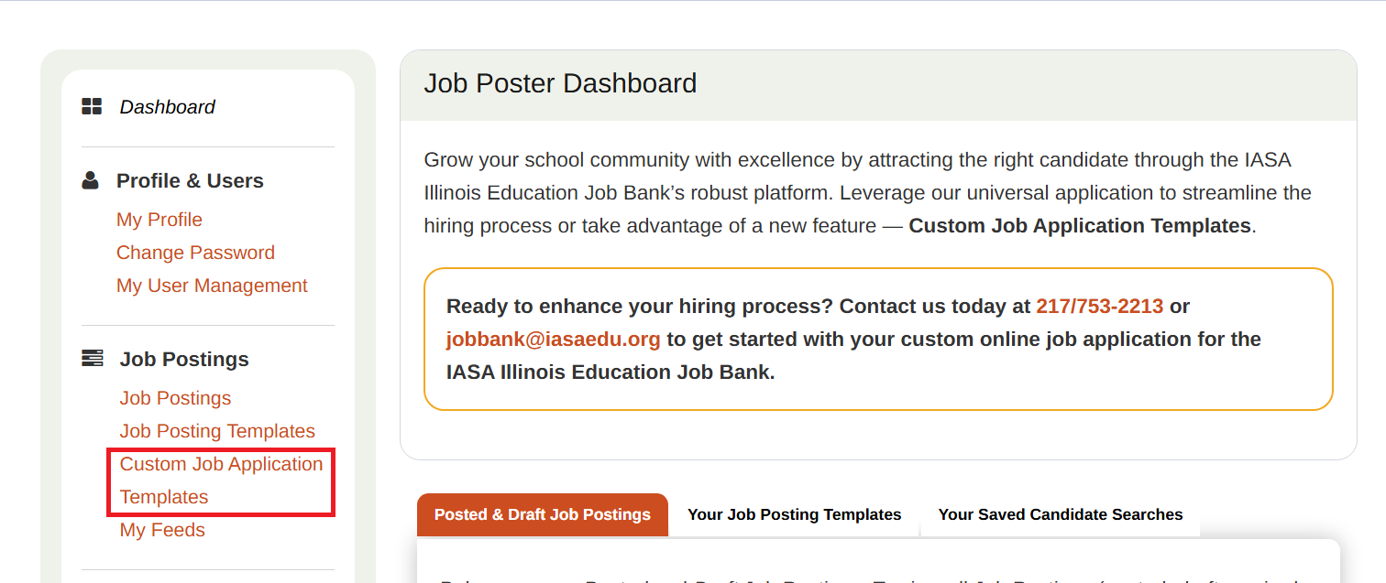
- Click on Custom Job Application Templates.

Step 2: Understand Template Types
In the Templates section, you will see:
- Master Application Template
These are the default “base models” that you can use to start all custom templates. There is one for certified staff positions and another for non-certified staff positions. Editing these templates will change the question for all future templates.
- Custom Job Application Templates
Here you can:
  - Copy existing templates
  - Edit templates you've already created
  - Delete templates you no longer need
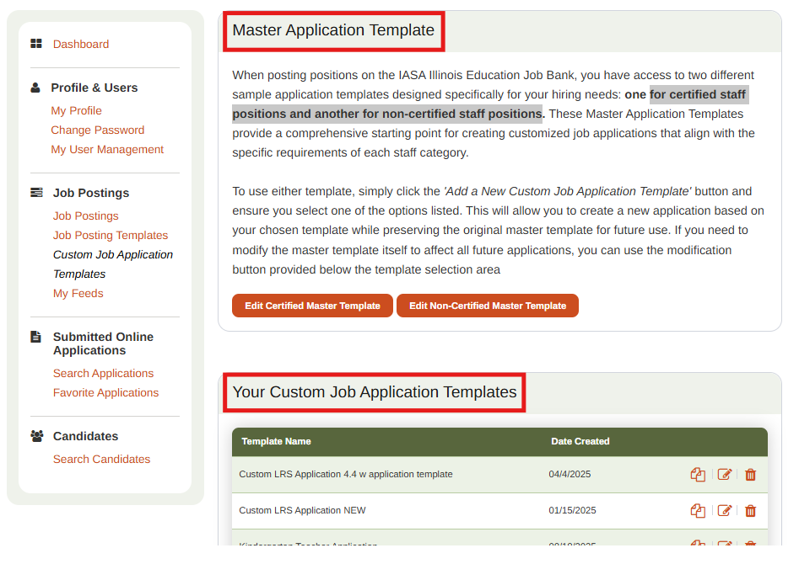

Step 3: Create a New Template
- Click the Add New Custom Job Application Template button at the bottom of the screen.
- Choose a base template:
  - Use Certified Master Template for certified roles (e.g., teaching positions).
  - Use Non-Certified Master Template for other roles.
- In the Application Template Name field, enter a name such as “Kindergarten Teacher Application”.
- Click Save Application Type at the bottom of the page.
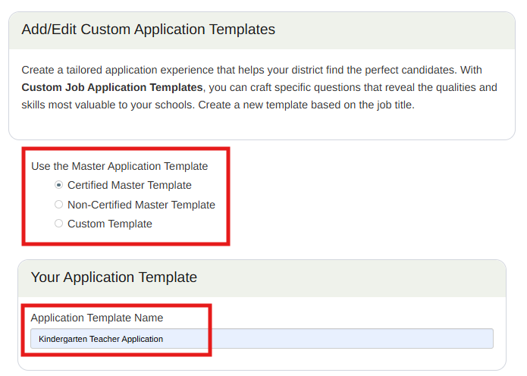

Part 2: Managing Sections and Fields

Step 1: Create and Organize Sections
- Click the + next to Manage/Add Sections to expand.
- In the section name field, enter a name:
  - Example: Additional Experience
- The Job Seeker Section dropdown can be left blank or an existing application section can be selected.
  - When a section is selected, the new section will appear in with the selected section in the printed application.
  - Example: For Additional Experience, select “Employment/Experience” in the Job Seeker Section to group accordingly.
- Click the Add New Section + button.
- Add additional sections as needed.
- Reorder the sections as needed by changing the numbers in the sort field and clicking “Save Sections”. They will appear in the correct numeric order.
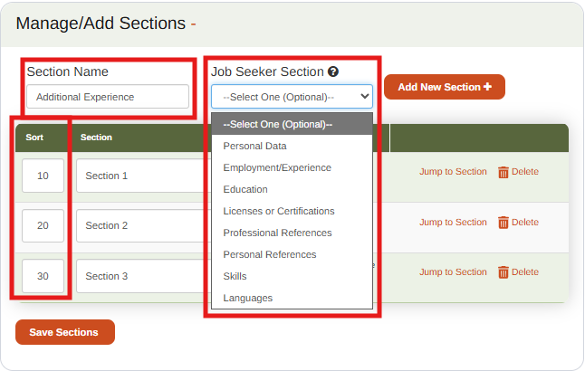

Step 2: Add Fields to Sections
After creating a section, you must add fields to collect applicant information.
Available Field Types:
- Text Field: Short answers (e.g., Name, Email)
- Text Area: Longer responses (e.g., "Describe your teaching philosophy")
- Instructional Text: Display-only notes or guidance
- Subsection Header: Adds a visual heading within a section
- Dropdown List: Choose from predefined options
- Radio Buttons: Single-select options (e.g., Yes/No)
- Checkbox: Single confirmation checkbox
- Checkbox List: Multi-select from predefined options

Selecting each of the options in the dropdown will show a brief description of the field type and show an example.

To add a Text Field, Text Area, Informational/instructional Text, Subsection Header or Checkbox:
- Navigate to the new section where additional fields are needed and click + Expand
- Click + Add New Field.
- Select Field Type.
  - Ex: Text Area
- Enter the Prompt/Question to the Label Field:
  - Ex: “Describe the most difficult situation you’ve dealt with in your training and how you resolved the situation.”
- Set Field Width:
  - This will determine how much space the field will take up on the page (full width, 3/4, 2/3, half, 1/3, 1/4) and allow multiple fields to be placed on the same line.
- Select the checkbox next to Required, if a response is required to this field on the application.
- Click Add Field.
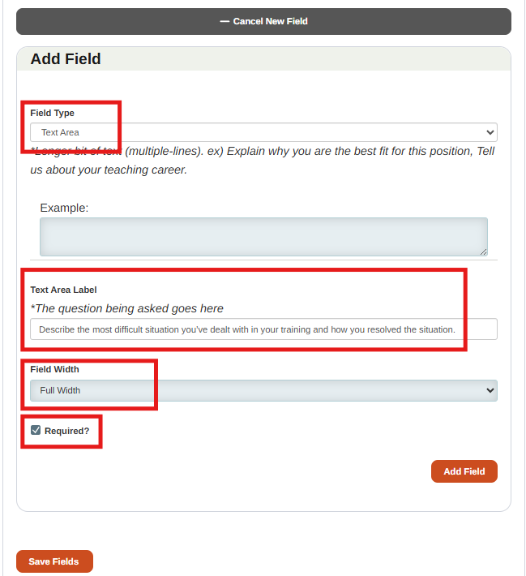

To add a Dropdown List, Radio Buttons, or Checkbox List:
- Navigate to the new section where additional fields are needed and click + Expand
- Click + Add New Field.
- Select Field Type.
  - Ex: Dropdown List
- Enter the Prompt/Question to the Label Field:
  - Ex: “What is your favorite color?”
- Enter List Values into the field individually and click Add after each one:
  - Ex: “Red”, “Yellow”, “Blue”, “Green”
- (Optional) Set a Default Value to be preselected for the applicant with the option to update
- Set Field Width:
  - This will determine how much space the field will take up on the page (full width, 3/4, 2/3, half, 1/3, 1/4) and allow multiple fields to be placed on the same line.
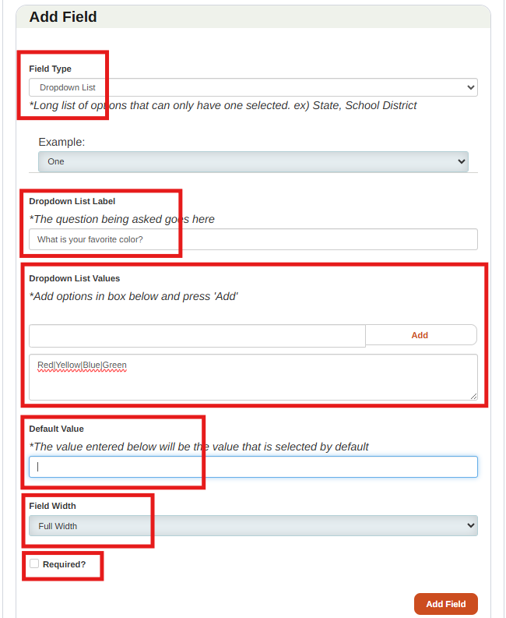
- Select the checkbox next to Required, if a response is required to this field on the application.
- Click Add Field.

Step 3: Manage Existing Fields
Once your fields are created, you can further refine the layout and functionality.
You can:
- Reorder fields using the sort number on the left
- Edit labels via the pencil icon
- Access additional settings (required, default values, etc.)
- Clone, delete, or close fields
Field settings vary by type:
- Text Field, Text Area, Informational/instructional Text, Subsection Header or Checkbox:
  - Can only mark require or not
- Dropdown List, Radio Buttons, or Checkbox List:
  - Can edit list values, default value, and mark as required or not

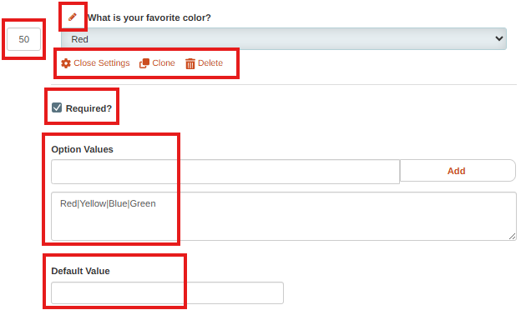

Step 4: Preview and Finalize the Application
- Scroll to the bottom of the page.
- Click Preview Application Template.
In the preview:
- Review questions for clarity and completeness
- Adjust field widths for visual flow (e.g., side-by-side first/last name)
- Confirm required fields are correctly marked

Final Steps
Once you are satisfied with the layout and content:
- Save any final edits.
- Your job application is now ready to publish and use for candidate submissions.

